**WHEATLEY HS JROTC DINNING-IN**

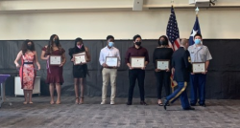

**Cadets being recognized for their hard work and dedication.**

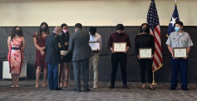

**Cadets being recognized for their hard work and dedication.**

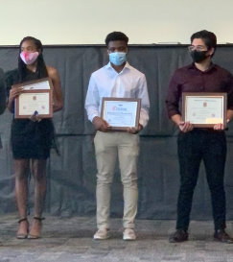

**C/SSG Joubert, C/CSMCayetano, and C/PFC Villanueva**

**Being recognized for their great Community Service during Food Distributions**

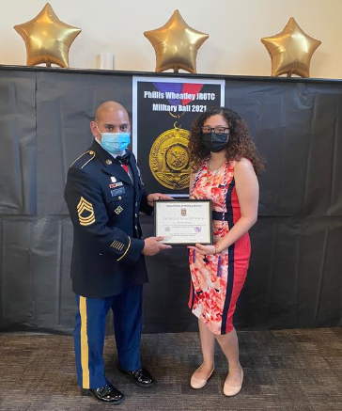

**After four years of great achievements as one of Wheatley Wildcats Cadets, C/SGT Sandoval was awarded the JROTC Honor Cord.**

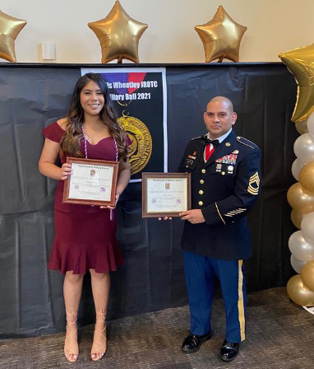

**After four years of a lot of hard work and dedication as one of Wheatley Wildcats Cadets, C/SGT Ramirez was awarded the JROTC Honor Cord.**

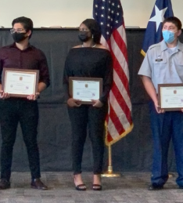

**Our Cadets continue to do great for our school and our community.**

**Upcoming Events: 27 May Food Distributions**